- Stadt.hub

Spatial organisation of post private car city

Cars sit unused 90% of the time. What if no one owned one at all? This project reimagines Wolfsburg, one of Europe's most car-dependent cities, as a place where all mobility is shared, electric, and autonomous: on-demand, fleet-managed, and accessible to every resident.

Prompt:
I'm working on a university project (M.Sc. Integrated Urban Development and Design) reimagining a car-dependent European city as a "post-car" future. I've picked a mid-sized German city — a classic "company town" built around a single dominant industrial employer, where the whole urban form grew up assuming everyone drives.
I don't yet know what the "solution" looks like — that's part of what I'm trying to figure out. Some directions I'm considering: better public transit, densification, congestion pricing, shared mobility, reclaiming street space for pedestrians/cyclists, or some combination. I'd rather the analysis point me toward what's actually feasible for this specific city's structure than start from a solution I like and retrofit the data to justify it.
So — practically — I want to build a tool (client-side web map, OpenStreetMap data, no backend) that lets me actually see the current state: where the car-dependency problems concentrate, which districts are cut off from alternatives, where the existing infrastructure (roads, transit, parking, land use) already has slack I could repurpose versus where I'd need something genuinely new. I want the diagnosis to come first, and I want it to be visual enough that I can keep looking at it and testing hunches, not just a spreadsheet of stats.
Once I actually understand the shape of the problem, I'll come back and we can talk about what to build for the solution side.

- MANIFESTO
The car is not the problem — ownership is. We don't remove cars from the city; we remove the requirement that every resident own a vehicle to access it.
Build on what exists, not what could be built. Every hub is sited on infrastructure the city already has — a parking structure, a bus stop — not on new construction. The network is a reallocation, not an expansion.
Access is hierarchical, not flat. A single mode cannot serve a city — large hubs carry the load between districts, small hubs carry it to the doorstep. Every tier has one job and does it at the right scale.
The periphery is not an afterthought. A network that only works in the center simply relocates the inequality it was meant to solve. Coverage is judged by its weakest district, not its average.
Street space returned to people is the actual deliverable. Fewer cars is not the goal — it is the mechanism. The goal is space back for pedestrians, cyclists, and public life.
Decisions follow data, not preference. Every hub placement, every catchment radius, every mode assignment is derived from measured demand and existing infrastructure — not from where a hub would look good on a map.

Promp:

How could you shortly imagine the "Manifesto" of the Stadt.hub project, taking into account its goals
Like maybe 1-2 strong and straight forward sentences

Stadt.hub is not a plan to remove the car from Wolfsburg — it's a plan to replace what the car was hiding: space, access, and a city built for people first.

Its not a manifesto. Manifesto is something that states the core idea of the project

- History and problem *INSERTED

Wolfsburg is a city built around automobile infrastructure. Volkswagen’s production has shaped not only the economy but also the city’s spatial logic: wide roads, fragmented districts, villages disconnected from one another. The result is social disintegration and total dependence on private cars.

Promp:
How could you highlight the problems that a car centric city like Wolfsburg could cause for the citizens?

- Analysis: Mobility Infrastructure

The transport activity map reveals Wolfsburg's satellite urban structure: a dominant core concentrating the majority of transport infrastructure and activity, surrounded by dispersed residential settlements with significantly lower intensity. This monocentric pattern, characteristic of company towns, reflects the historical gravitational pull of the VW Werk. Peripheral districts exhibit limited autonomous transport capacity, with movement directed primarily towards the central hub rather than distributed across a polycentric network.

Auto network:
Wolfsburg is a car-oriented city with a high modal share of private automobile use. Despite its spatially fragmented structure — a monocentric industrial core surrounded by dispersed residential settlements — the road network provides comparatively strong connectivity. Traffic intensity converges towards the VW Werk and the city centre, reproducing a classic hub-and-spoke pattern characteristic of company towns.
Public transport:
Despite its car-centric spatial structure, Wolfsburg maintains a functional public transport network that connects peripheral residential districts to the urban core. The bus system provides a degree of spatial equity, offering mobility access to residents without private vehicles. Route intensity concentrates along the main corridors linking outlying settlements to the city centre and the VW Werk, reinforcing the monocentric character of the city's transport demand.
Cycling:
The cycle network shown represents the planned cycling infrastructure sourced from the Wolfsburg Geoportal. The existing network currently covers primarily the city centre and its immediate surroundings. The planned routes are intended to extend cycling connectivity to outlying residential districts, addressing the current modal gap in active mobility. For the spatial analysis, the dataset currently registered in OpenStreetMap was used as the analytical baseline.

Prompt:
We want to build the first analysis layer for my post-car mobility project: Mobility Infrastructure. This is the baseline diagnostic — before we propose any solution, we need to see how the city currently moves.

- Analysis: Livability & Facilities
The majority of urban civic and commercial facilities are concentrated in the central districts — Stadtmitte, Schillerteich, and Laagberg — which form the functional core of the city. Peripheral settlements such as Vorsfelde, Fallersleben, Hehlingen, and Nordsteimke exhibit significantly lower facility density. This spatial imbalance not only reflects the historical planning logic of a company town, but also compels residents of outlying districts to rely on private automobiles for everyday activities, reinforcing car dependency at a structural level.

Land use
Wolfsburg's land use structure reflects its identity as a satellite city shaped by industrial planning. Large agricultural and forest zones — Farmland, Meadow, and Forest — fragment the urban fabric and physically separate residential districts from one another. The commercial and civic core remains concentrated in the city centre, while industrial land — dominated by the Volkswagenwerk — occupies a significant share of the built environment. This land use pattern reinforces spatial segregation and reduces the conditions for walkable, mixed-use urban life outside the centre.

Activity
Activity intensity at registered venues confirms the centralised structure of Wolfsburg's urban life. Peak activity concentrates in the city centre and around major commercial destinations, while peripheral districts show sparse and low-intensity patterns. This reflects both the limited provision of local facilities in outlying areas and the dependence of residents on centralised services, reinforcing the city's monocentric character and the role of the automobile as the primary enabler of daily mobility.

Prompt:
Now we want the second analysis layer: Livability & Facilities. If Mobility told us how people move, this one should tell us what they're moving toward — where daily life actually happens in the city, and where it doesn't.

Centralities
Peak multi-modal accessibility — excluding the private car — is currently the privilege of residents in the central districts of Stadtmitte, Schillerteich, and Laagberg. The combined score reveals a steep spatial gradient: even a modest displacement from the urban core sharply reduces the share of amenities reachable on foot, by bicycle, or by public transport within 15 minutes. This pattern reflects the structural car dependency embedded in Wolfsburg's dispersed, monocentric urban form — the road and settlement configuration imposes a de facto mobility barrier on those without access to a private vehicle.

Walk
Pedestrian accessibility is concentrated almost exclusively in the urban core. The 15-minute walking catchment captures a significant share of amenities only in the innermost districts; beyond these, inter-building distances and the dominance of road infrastructure over pedestrian connectivity reduce walkable access sharply. For the majority of Wolfsburg's residents, the car is a functional necessity rather than a choice.
Bike
Cycling extends the effective accessibility catchment considerably compared to walking, but the gap between the planned and existing cycling infrastructure — particularly in outlying districts — constrains this potential. Within the centre, cycling scores are competitive with public transit; in peripheral settlements, the absence of dedicated cycling routes and the hostile road environment suppress modal uptake.
Public
Public transport accessibility mirrors the monocentric convergence visible across all modes. Bus routes radiate from the city centre and the VW Werk, providing adequate coverage along major corridors while declining sharply in secondary residential areas. The system supports commuting to key destinations but offers limited flexibility for non-radial journeys or off-peak travel, restricting its role as a genuine car alternative for daily mobility.
Auto
Automobile accessibility is near-uniform across the entire city — a direct consequence of Wolfsburg's road network design. Within a 15-minute drive at 50 km/h, virtually every amenity is reachable from any location. This structural equality of motorised access is precisely what has suppressed the development of alternatives: the car performs so efficiently that the network has never required the density, mix, or walkability that typically sustain other modes.

Prompt:
Now we want the third analysis layer: Centralities. Mobility showed us the infrastructure, Livability showed us the destinations — now we want to actually measure accessibility: given the infrastructure and the destinations, who can reach what, and how does that change depending on the mode of transport they're forced to use?

- VISION *INSERTED
<Future of mobility as service>

Shared
Vehicles are accessed on-demand rather than owned — pooled cars, e-bikes, and pods serving many users instead of sitting idle 90% of the time. Cuts the number of vehicles needed per resident, frees up land currently used for private parking, and makes mobility accessible to those who can't or don't want to own a car.

Autonomous
Self-driving shuttles and pods operate without a human driver, enabling on-demand, 24/7 service at a much lower marginal cost per trip. Removes the labor-cost barrier that makes small, flexible, low-density routes uneconomical today — meaning frequent, direct service becomes viable even in peripheral districts.

Electric
All shared/autonomous vehicles run on electric drivetrains, charged at hub depots. Eliminates tailpipe emissions and local air pollution, and — paired with autonomous fleet operation — allows continuous, centrally-managed charging cycles that keep the fleet running efficiently around the clock

Prompt:
If existing mobility patterns are constraining the city, how can we change the mobility typology without harming the connections that already hold the inner city together?

- VISION
Wolfsburg gives a disproportionate amount of urban land to private cars: parking lots, surface parking, on street parking, and car-oriented street infrastructure. This is amplified by Volkswagen’s commuting patterns — the city was literally built around car storage and car movement. The project argues this land-use model is no longer necessary. If mobility is reorganized around a shared, multimodal, autonomous system, the land currently used for parking becomes available for public life, greenery, housing, and civic space.
Prompt: Generate visualizations of how Wolfsburg's urban environment could transform following the introduction of a new mobility typology.

- VISION
According to the calculation, this amout of trip could be served by 1.300 shared vechicular, replacing 50,000 private units
‘Here could be the picture of cars before and after’
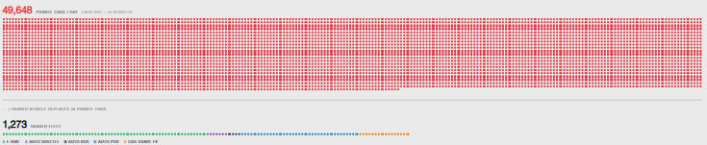

Possible outcome

Shared vehicles in fleet | 1,300 | 641 e-bikes · 55 shuttle pods · 33 buses · 369 micro-pods · 175 EVs
Trips served per day | 104k | 17,400 residents (in the city center) + 18,000 workers (daily commuters) + 7,080 daily visitors
Saved per household / year | 7,596 € | €727/mo private car → €94/mo shared mobility · 87% cost reduction · ADAC 2024 / MOIA Hamburg

Prompt: what could be possible outcomes after this type of interventions.

- <VISION: HUB>
Cover: hub system (either to put ithorizontal or vertical?)
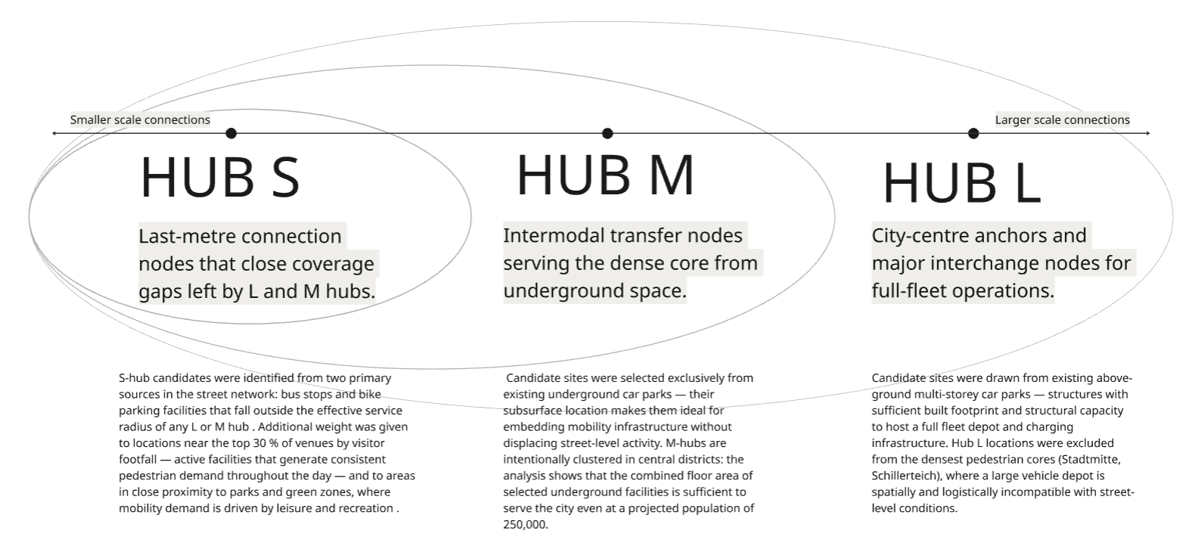
2nd page: explanation
Mobility hubs are defined as
“highly visible, safe and accessible spaces where public, shared and active travel modes are co-located along side improvements to public realm and community fa cilities” (reference: 3. COMODAL. (n.d.). Introducing the mobility hubs concept. https://www.como. org.uk/news/introducing-the-mobility-hubs-concept)

They are interchanges where transit, cycling/walking, and shared transport (car clubs, bike-share, e-scoot ers) meet — and they redesign space to reduce pri vate-car space and improve public realm. In our project we intruduce a three-tier hub system: S - M - L system covers different types of mobility wit hin the city borders with focus on city center (Stadtmitte), where the demand on trips is the highest. In this project we adopt hub idea to the Wolfsburg´s limits, demands and future vision of sustainability.

Prompt: What hub system architecture would suit a project like this, where multiple mobility types must be integrated into a single, cohesive system?

- <VISION: HUB>

City connection through the HUB system

Cover: Hub image
Second page:
A three-tier shared mobility network enabling seamless mode-chaining across the city — e-bike, autonomous shuttle, and shared pod — without a private vehicle.

Hub network
By introducing the hub network, the city gains the opportunity to become progressively more connected — beginning with districts closest to the centre, and gradually extending mobility coverage to more remote settlements as the network expands. The hub system makes different modes of mobility structurally available across all districts, reducing car dependency at the network level.

Facility network
The facility network analysis shows that proposed hub locations substantially improve non-motorised access to urban amenities across all districts. Areas where current walking and cycling accessibility scores are lowest — peripheral residential districts — benefit most from hub-mediated connectivity. Hub placement transforms mobility gaps into connected catchments, enabling residents to reach everyday destinations without a private vehicle.

External Flows
Integrating external commuter flows into the hub network is critical for reducing the volume of private vehicles entering the city. By positioning Hub L nodes at the main entry points, the system creates a seamless transition from regional transport to the internal shared mobility network — making it practical for Einpendler to leave their cars outside the city boundary and complete their journey by shared mobility means.

Prompt: How hub system affect the inner city connections?

- <MASTERPLAN>

The project covers the city's central district — Stadtmitte — not only through the hub system, but also through a proposal for a new pattern of traffic movement. Hub M nodes create points of car attraction along the district's periphery, freeing the streets within the district from car flows. Hub S nodes connect to Hub M in such a way that a private car is no longer needed here: any point can be reached from any other using one of the shared mobility modes. Streets freed from cars become the focus of urban design interventions. This applies especially to Porschestraße — it becomes not only the main focal point of the district, but also the connecting link between the southern part of the city and the part of the city on the other side of the river.
Prompt: how the city center could get transformed after new transport system implementation.

- <MASTERPLAN. CONNECTIONS>

Hub L — the city-scale anchor
Hub L nodes sit at the top of the hierarchy, positioned at the city's main entry points and largest trip generators — where incoming commuters, regional traffic, and cross-district demand converge. They're spaced far enough apart (≈4 km catchment) to each serve a whole sector of the city rather than a single district. Between Hub L nodes, connections run on the highest-capacity mode — an autonomous bus line — carrying the heaviest, longest-distance flows across the city.
L → M — distribution into districts
From each Hub L, the flow is handed down to the Hub M nodes within a ≈1.5 km radius, via shuttle and pod. This is where city-scale traffic is broken down into district-scale traffic: a Hub L doesn't try to serve every street itself — it delegates that job to the Hub M tier, each covering roughly a 2 km catchment centered on a district core.
M — the district-scale relay
Hub M nodes also connect to each other (M ↔ M, ≤1 km, shuttle + pod) where districts are adjacent, allowing lateral movement between neighboring areas without needing to route back through a Hub L. This is the "middle layer" of the network — it absorbs the volume from Hub L and redistributes it locally, while also giving districts a way to talk to each other directly.
M → S — the last handoff
From Hub M, the connection narrows again: pod and e-bike carry the flow out to Hub S nodes within a ≈600 m radius. This is the point where city-scale infrastructure becomes street-scale — the mode shifts from shared vehicles to individual, human-scale mobility (e-bike, walking distance to a pod).
Hub S — the final mile
Hub S nodes sit at the base of the hierarchy, each with a small ≈400 m catchment, placed directly at bus stops and last-mile demand points. S ↔ S connections (≤400 m, e-bike only) stitch neighboring Hub S nodes together for genuinely local, block-to-block trips that never need to touch the upper tiers at all.

Prompt: Could you describe how Hub L, M, and S interchange at the city scale — starting from L, down through M, to S — outlining the hierarchy of connections between them?

